EPM Project
Weekending: 07/10/05
Project Overview
Project Number | 05-133 |  | Client Contact Name
Project Start | 02/07/05 |  | Project Manager
Project Target | 07/22/05 |  | Account Manager
Schedule Status | On Track |  | Budget Status | On Track

Project Description
The IT Operations team at InfoSpace would like to implement an Enterprise Project Management (EPM) solution for better management of their project portfolios and their project resources, in order to improve strategic prioritization of their corporate initiatives. We will deploy a pilot for IT Operations that can serve as a model and first step for EPM across InfoSpace. The desired goals for this pilot are:
- Reporting and management across their portfolio of projects
- Tracking and reporting of Key Performance Indicators (KPI’s) for Work Budget and Schedule
- Development of initial solution for resource allocation, capacity planning, and work leveling
- Business Process development to support the successful deployment of these EPM goals
- Training for EPM pilot team

Current Activity Update
Tasks Complete or in Progress this Status Period
- Brown bag session complete

Upcoming activities:
- Team member training to take place 2nd week of July

Current Project Financials
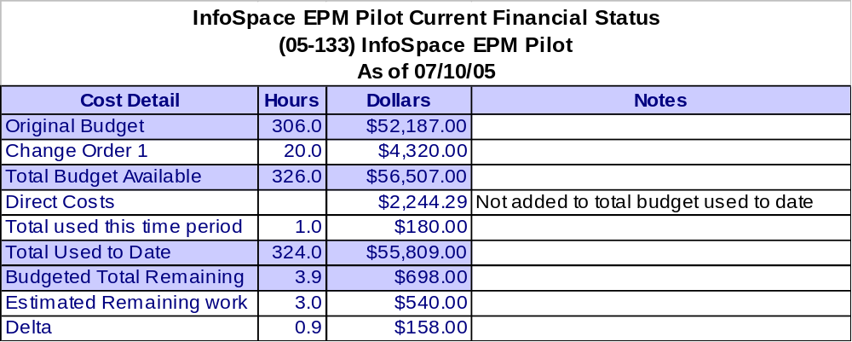

Note: Invoices to date:
Date | Number | Amount
06/21/05 | inv# 13096 | $3,030.00
06/15/05 | Inv# 13074 | $4,912.50
06/09/05 | Inv# 13040 | $12,438.83
05/26/05 | Inv# 12934 | $8,800.00
05/11/05 | Inv# 12865 | $6,700.00
05/10/05 | Inv# 12816 | $8,190.00
04/15/05 | Inv# 12709 | $1,830.00
03/31/05 | Inv# 12594 | $3,780.00
03/17/05 | Inv# 12561 | $3,390.00
02/28/05 | Inv# 12452 | $3,915.00
Total |  | $56,986.33

Current Risks, Action Items, Issues, Decisions, Changes, Business Process, and Training

Risks
Opened-ID | Risk / Update | Trigger Event to Watch | Probability | Impact | Overall
04/01/05-A | Project Slipping | Resources unavailable to meet project commitments | High | High | High

Action Items
Opened-ID | Action Items / Updates | Owner | Target Date  Status
05/09/05-A | User Workstation Solution – All Project and Resource Managers will need to have MS Project Pro 2003 installed, configured, and tested. We have determined that this will be a completely manual process, and will impact every Project Manager during the pilot. | Brian Jeide | 05/26/05  Closed
05/03/05-A | Randall is going to send the Spreadsheet for Resource Managers | Randall Rusher | 05/07/05  Closed
05/03/05-B | Install will take place the 16th and 17 – We need to confirm Chris Johansen will be available | Brian Jeide | 05/07/05  Closed
05/03/05-C | LJ is going to send some project schedule templates  Update: Received | Brian Jeide | 05/07/05  Closed
05/03/05-D | Will need to meet on the 18th for a walk-through – Brian will schedule a two hour meeting | Brian Jeide | 05/07/05  Closed
05/03/05-E | There is a PC on the network available to the installation team for testing and verification. | Brian Jeide | 05/07/05  Closed
04/19/05-A | Brian needs to select a team of 3 or 4 decision-makers to make all configuration decisions including:  - Identify and define any custom fields for enterprise, project, and resources  - Identify and define project status variables  - Define project types  - Define project phases  - Clarify and validate department list  - Need to clarify and validate locations. Do they need to be applied to resources?  - Decide how InfoSpace wants to manage and track non-project work  - Define the project-level template components and design for the Windows SharePoint Services environment  - Define process for project-level notes field | Brian Jeide | 04/22/05  Closed

Issues
Opened-ID | Issues / Updates | Owner | Target Date  Status
05/23/05-A | Mike Lamb needs VPN Access to InfoSpace network for remote support | Brian Jeide | 05/31/05  Closed

Decisions
Date-ID | Decision Log | Owner
06/02/05-A | We don’t need a role assigned to every resource during the pilot period. | Brian
05/03/05-A | Resource calendars: We aren’t bringing resources in yet. Start the standard calendar at 6 hours per day and wait for EPK suite for the final solution | Brian
05/03/05-A | Will make email place holder field for test and pilot for Resource Managers | Brian
05/03/05-B | - Install will take place the 16th and 17 – Need Chris Johansen available  - Will need to meet on the 18th for a walk-through – Brian will schedule  - 2 day – PM & RM Training will be the 26th and 27th (6 hours each day)  - Level set on why we are doing this – the Business Process  - 1 day PS Admin training (6 hours) – May 31st  - Week of Jun 13th – 2 hour Executive training | Brian
04/19/05-A | InfoSpace wants to add milestone and project level Traffic Light Indicators (TLIs) and train project personnel on the process for update and management of the TLIs. Do you want to set them manually or calculated? | Brian Jeide
04/19/05-B | InfoSpace wants to design and implement a standard WSS template for each project. | Brian Jeide
04/19/05-C | They don’t need resource skills at this time. | Brian Jeide
04/19/05-D | Project progress is going to be tracked with % complete and hours to complete. | Brian Jeide
04/19/05-E | Issues need to have a department field to allow grouping. | Brian Jeide

Change Log
Date | # | Change Title | Status
 | 1 | Change presented to cover adding Test server | Approved

